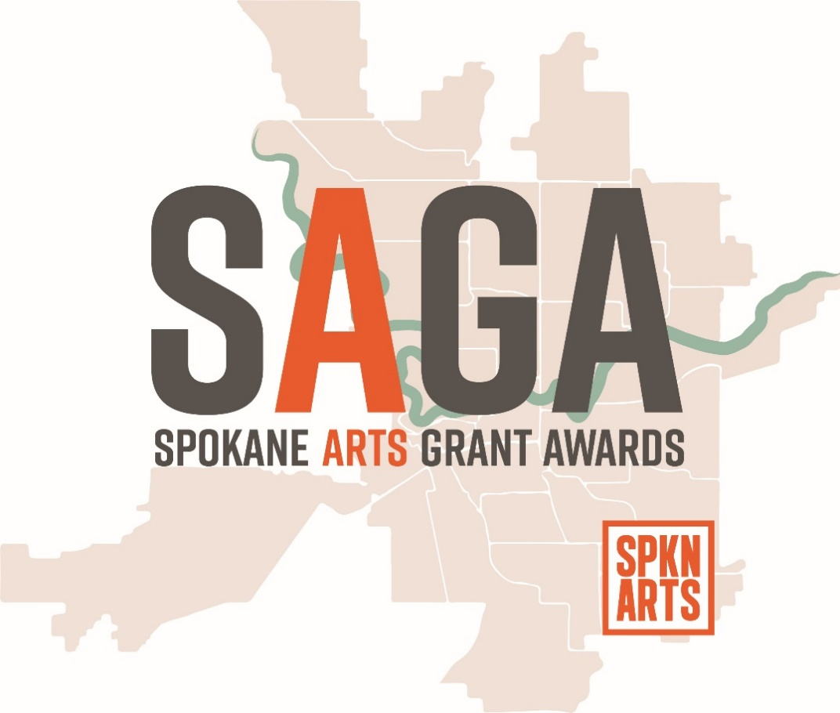

LARGE ORGANIZATION
GRANT APPLICATION TEMPLATE

PLEASE NOTE: This is NOT the application to be filed with Spokane Arts.
SAGA applications are accepted ONLY through our online application portal. Please visit http://www.spokanearts.org/grants for more information.
This document is offered only to assist in reviewing application questions offline, between formal opening dates, and for composing essay questions offline. It is a “best practice” to compose essay responses with access to spelling and grammar tools, and where you can more easily share your application with editors and collaborators. To encourage best-practice grantwriting, we offer this template.
Throughout this template, questions allowing answers of up to 100 words (or more) will be indicated in ORANGE, as a prompt to compose those answers in this document and transfer your finished responses to the online application form when you are satisfied with your answer.
For your information, the entire application is presented here, including optional sections you may not need when actually applying. Uploads required for the application must be managed in the online application itself. You cannot use this form to upload documents.
Save often and remember, our Grants Administrator is here to help! grants@spokanearts.org
LARGE
ORGANIZATION
APPLICATION
TEMPLATE
SAGA for Large Organizations
Annual Deadlines:
February 01 2019 at 11:59 PM PST (Midnight)
June 01 2019 at 11:59 PM PST (Midnight)
October 01 2019 at 11:59 PM PST (Midnight)

- Contact Information
Name of person filling out this grant application form:
First name, Last name *
Name of Organization

PRIMARY CONTACT INFORMATION:
First Name, Last Name *
Email: *
Address Line1: *
Address Line2:
City: *
State: *
Zip Code: *
Phone Number *
Cell Phone
Website
What is your preferred method of contact? *
Phone
Email
Other
Other Contact information

- About
Art Discipline
Indicate your art discipline category: *
Arts Service
Crafts
Dance
Humanities
Interdisciplinary
Media Arts
Music
Performing
Storytelling
Theater
Visual Arts
Writing
Other
You may check multiple categories.

Do you have any partners related to this grant proposal, either arts-related or non-arts-related? If so, please list and describe the nature of the partnership. Max Number of Words: 200
Click here to enter text.

- Grant Request
Requested Amount
Amount you are requesting from SAGA: *
$
(Max range: 10000)

Grant Funding
If you do not receive grant funding from SAGA, will you proceed with your project/event or be able to operate? * Max Number of Words: 300
Click here to enter text.

Have you applied for other grants for this proposal? *
Yes
No
Will Apply
4. Grant Proposal
Grant request in US dollars:
Description and Narrative
PROPOSAL TITLE: * Max Number of Words: 15

SUMMARY:
Please provide a short, 25-word description of your proposal. * Max Number of Words: 25

PROPOSAL NARRATIVE:
Please describe the purpose of this request and how you will use SAGA funding. Please be specific in the description. * Max Number of Words: 1500
Click here to enter text.

BACKGROUND:
How is your history as an artist, collective, or organization built upon, expanded, or redirected with the proposed work? * Max Number of Words: 500
Click here to enter text.

What other information should we know? Max Number of Words: 200
Click here to enter text.

5. Events
Instruction
Are you applying for a grant to support one or more events? *
Yes
No
Event Details
Is this a single event or multiple events?
Single
Multiple
Other
Name of event(s):
Date of event(s):
Provide a brief 2-3 sentence summary of the proposed event(s), including projected number of participants and event website, if applicable. Max Number of Words: 100
Click here to enter text.

Are you charging a fee for tickets/reservations? *
Yes
No
How much are you charging per ticket?
$
Please describe the details included in your ticket price(s):
What do you want participants to take away from this event? How will you know if you were successful? Max Number of Words: 200
Click here to enter text.

Please describe your venue, if applicable. Max Number of Words: 200
Click here to enter text.
6. OPTIONAL: Timeline and Impact
Instruction
The Timeline and Impact section of this grant application is optional.
Would you like to share timeline and impact information with the selection panel? *
Yes
No

Timeline
What is the project's timeline?
Please describe what you will accomplish during the projected grant year. Max Number of Words: 500
Click here to enter text.

Impact and Results
Please describe the impact of your proposal. Max Number of Words: 500
Click here to enter text.
7. OPTIONAL: Promotion and Marketing
SAGA allows a grant period of up to one year from the Award Date. The one-year period is intended to allow an applicant adequate time to plan, execute, and report out its project or proposal. Please refer to the current SAGA calendar to ensure you discuss the correct timeframe.
Instruction
The Promotion and Marketing section of this grant application is optional.
Would you like to share promotion and marketing information with the selection panel? *
Yes
No
Promotion or Marketing Plan
UPLOAD OR DESCRIBE YOUR PROMOTION OR MARKETING PLAN:
Select File
Maximum File Size: 10MB
Plan description: Max Number of Words: 500
Click here to enter text.

Upload any promotional materials you may have already created:
Select File
Maximum File Size: 10MB
Additional promotional materials:
Select File
Maximum File Size: 10MB
Promotional links: Max Number of Words: 100
8. Organization Information
The following questions will not be used to determine your eligibility to receive grant funding, but instead, will be used to help Spokane Arts in our data collecting for our region.

How many full-time employees? *
2-5 people
6-15 people
16-30 people
More than 30 people

Please enter your nine-digit EIN Nonprofit number. *

How many years have you been operating as a nonprofit? *

Please upload your most recent annual budget approved by your board of directors/ board of trustees. *
Select File
Maximum File Size: 10MB
PDF preferred.
What is your Fiscal Year End date? *

Please list the names of your board of directors/ board of trustees. *

Name of Executive Director *

Email of Executive Director *

Phone number of Executive Director *
9. Primary Artists
Please tell us about the primary artist(s) involved in your proposal. * Max Number of Words: 1000
Click here to enter text.

OPTIONAL:
Please list the artist/s’ professional awards, including residencies, fellowships, prizes, etc.
Max Number of Words: 2000
Click here to enter text.

Or upload the artists’ CVs.
Artist #1’s CV:
Select File
Maximum File Size: 10MB

Artist #2’s CV:
Select File
Maximum File Size: 10MB

Artist #3’s CV:
Select File
Maximum File Size: 10MB
10. Artistic Samples
Applicants must submit at least one artistic work sample.
Please upload at least one artistic sample, which can represent past work, or represent the proposal for which the grant will fund. This is a required component of applications and may provide the grant Selection Panel with a deeper understanding of the work.
Artistic Sample 1
Select File
Maximum File Size: 10MB
Description of Artistic Sample 1

Artistic Sample 2
Select File
Maximum File Size: 10MB
Description of Artistic Sample 2

Artistic Sample 3
Select File
Maximum File Size: 10MB
Description of Artistic Sample 3

Artistic Sample 4
Select File
Maximum File Size: 10MB
Description of Artistic Sample 4

OPTIONAL: The following spaces are for you to use if you would like to provide a link.
Artistic Sample Link to video or website 1
Artistic Sample Link to video or website 2
Artistic Sample Link to video or website 3
11. Budget
Operational Support
SAGA will fund Project Support or Operating Support. If you choose "yes" to the following question, the Project Support budget will disappear, and you will be required to answer the Operating Support portion of the application only.
Are you requesting General Operating Support only from SAGA? *
Yes
No
General Operating Support refers to a grant to support your day-to-day operations. This is also known as unrestricted or core support as it allows the grantee to use the funds to strengthen their own core work or to further their purpose as they see fit.
Do not select "Yes" if you are also seeking support for programming, and/or projects. See our guidelines for more information.
Please upload your personal Basic Strategic Plan that covers one or more years, includes goals, and shows a work plan. Your short plan should include the following:
* A vision of your role in making a difference in the Spokane community.
* How will SAGA funding will contribute to your development (or to your overall goals)
* A justification for why you are asking for operational support only, and why it is a good investment for SAGA.
* Expenses for the next year *
Select File
Maximum File Size: 10MB

OPTIONAL: If you have an additional upload, for example, a separate budget, or expense list, you can use this space.
Select File
Maximum File Size: 10MB

Please describe the above upload. Max Number of Words: 200
Click here to enter text.
Budget for non-operational support requests (Project budgets)
INCOME: In-Kind Support
Total In-Kind Support toward your proposal *
Click here to enter text.

INCOME: Pending Funds and Sources
Total funds requested that are pending, but not yet committed and sources: *
Click here to enter text.

INCOME: Funds Committed and Sources
Total funds already committed and sources: *
Click here to enter text.

EXPENSES: Funds needed
Detailed project expense budget (showing all expenses): *
Click here to enter text.

Just the Numbers
Grant Request (this number will auto-fill from the Grant Request section)
$______

INCOME: Total income from Pending sources
$______

INCOME: Total income from committed sources
$______

EXPENSES: Total of all expenses
$______

Difference between the INCOME and EXPENSES.
$______ (this number will auto-calculate)
12. OPTIONAL: Letters of Support
LETTERS OF SUPPORT ARE OPTIONAL.
Letters of support may be helpful for the selection panel if you (or your group) are applying for a grant in which there is a partnership component, or if you have a fiscal sponsor. Letters of support can also help clarify community impact.

Do you have letter/s of support to share with the selection panel? *
Yes
No

Letter of Support 1
Make sure the letter of support Includes the identity of the supporter, and the nature of the relationship.
Select File
Maximum File Size: 10MB

Letter of Support 2
Make sure the letter of support Includes the identity of the supporter, and the nature of the relationship.
Select File
Maximum File Size: 10MB

Letter of Support 3
Make sure the letter of support Includes the identity of the supporter, and the nature of the relationship.
Select File
Maximum File Size: 10MB
13. SAGA History
Have you applied for a SAGA grant in the past, for this, or any other project? *
Yes
No

As the primary grant writer on this application, how would you describe your grant writing experience? (Including your experience with SAGA, for yourself or others.)
This information is for demographic purposes only, and is not shared with the selection panel. *
First-time grant writer
Have written grants, never won
Have written applications, which were awarded, totaling less than $10,000
Have written applications, which were awarded, totaling up to $50,000
Have written applications, which were awarded, for more than $50,000 total
Professional Grant Writer

14. Certification/Permission to Release Information
By submitting this application, I hereby certify that all information submitted on this application is true and accurate to the best of my knowledge. *
Yes, I certify that all information is true and accurate.
I agree to provide a timely and detailed report to Spokane Arts regarding how the SAGA funds were used. *
Agree
I agree to be photographed and interviewed, and to appear in public at Spokane Arts events, and that photos and/or media will be used to promote SAGA. *
Agree
I agree that these application materials may be used in whole or in part (with all sensitive information redacted) to help announce the project if selected for funding, and/or to provide positive examples so others can improve their grantwriting. *
Agree
Significant changes in the scope of my request may result in cancellation of the grant. If funded, I agree to contact Spokane Arts immediately if changes are necessary. If the original grant description for which funds were awarded is cancelled, I understand the grant will be cancelled and all monies paid will be returned to Spokane Arts. *
Agree

Electronic Signature of Authorized Official
I certify that I understand the terms of the grant application. *
Please type your name

Authorized Official: The individual, named by the applicant or organization, who is authorized to act for the applicant and to assume the obligations imposed by the laws, regulations, requirements, and conditions that apply to SAGA grant applications or grant awards.

